COPYRIGHT CHECKLIST 

www.nettax.in | Connect with us: 1800 890 4841

WHAT IS COPYRIGHT?

Copyright is the exclusive and assignable legal right, given to the originator for a fixed number of years, to print, publish, perform, film, or record literary, artistic, or musical material.

# Beneﬁts of Registering Copyright:

1. It ensures certain minimum safeguards of the rights of authors.
2. It establishes a public record of the copyright holder’s ownership.
3. It provides legal evidence of ownership.
4. It helps, a copyright holder to bring a lawsuit for copyright infringement.
5. Without the copyright registration, only an award related to actual damages and profits will be made available in case of litigation.
6. It permits the copyright owner to record the registration with Indian Customs to help in protection against the importation of infringing copies into India.
7. Owner can sell or pass on the rights of the work to the other person with copyright protection.
8. Copyright is permanent in nature and will exist for life time of the creator plus 60 years after death of creator. The validity of copyright registration will lifelong and after 60 years after death of creator it will be open to general public to imitate or reproduce the content freely.

# List of documents required for Copyright Registration:

1. 2 Copies of work
2. DD/IPO of Rs. (as applicable) per work
3. NOC from author if applicant is diﬀerent from author.
4. NOC from publisher if work published and publisher is diﬀerent from applicant.
5. Search Certificate from Trade Mark Office (TM -60) if the work is being used on goods or capable of being used on the goods.
6. NOC from person whose photograph appears on the work.
7. If the application is being filed through attorney, a specific Power of Attorney in original duly signed by the applicant and accepted by the attorney.

www.nettax.in | Connect with us: 1800 890 4841

# Deliverables: -

1. List of documents (For benefited)
2. Copyright Registration Handbook (For benefited)

# Turn Around Time (TAT):

* + Copyright Application when filled, candidate gets a copyright diary number, which is legal proof of the application.
  + Copyright office keeps the application open for 30 days for objection.
  + If no objection is received from any party, it typically takes 8 to 12 months for Copyright Certifi- cate to be issued.

# Cost of Service: -

The copyright fees depend upon the type of work to be copyrighted, as the Govt. charges change according to type of work.

www.nettax.in | Connect with us: 1800 890 4841

# Questionnaire for Copyright

This basic information will be while applying for Copyright.

Applicant Name: (Write the name of Company or Firm or Individual, in whose name the trademark to be

registered)

Nationality: Mobile No:

Email Id of the Applicant:

Service Address :

Nature of The Applicant’s Interest in the Copyright of The Work:

Title of the Work:

Language of the Work:

Whether Work Is Published or Unpublished? YES NO

Year and Country of First Publication and Name, Address and Nationality of the

Publishers

www.nettax.in | Connect with us: 1800 890 4841

**Good Luck**

**For Your Business**

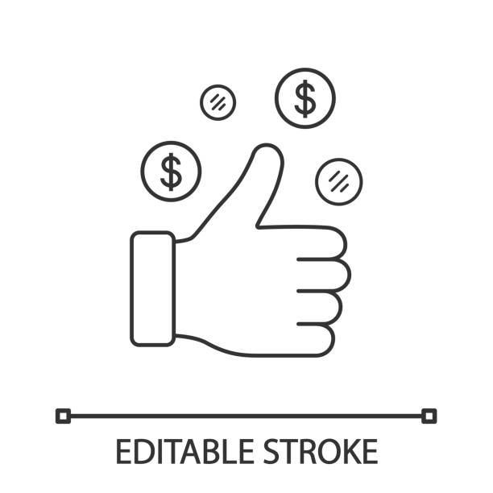

Shop No 5, 1st Floor, Vallabh Vihar Park, Nr Bhagirath

bungalows, Vijay Park BRTS, Ahmedabad - 382345

www.nettax.in | Connect with us: 1800 890 4841