UDYAM REGISTRATION CHECKLIST



www.nettax.in | Connect with us: 1800 890 4841

Any business that falls under the Micro, Small or Medium (MSME) category and wants to get registered as an MSME, needs to get an Udyam Registration Certificate. The Micro, Small and Medium Enterprises Development Act says that a business can be termed as an MSME if its turnover and investment is within the following limits:

|  |  |
| --- | --- |
| **Micro** | Investment less than Rs. 1 Crore and turnover less than Rs. 5 Crores |
| **Small** | Investment less than Rs. 10 Crores and turnover less than Rs. 50 Crores |
| **Medium** | Investment less than Rs. 50 Crores and turnover less than Rs. 250 Crores |

Earlier, to get recognized as an MSME, businesses had to get an “Udyog Aadhaar”, which was replaced on 1st July, 2020 by “Udyam Registration”.

**Steps to apply for Udyam Registration:**

**Step 1**: Visit the Official Website.

**Step 2**: Aadhaar Verification

* Enter the Aadhaar number and name (as appearing on the Aadhaar card) of the person/representative applying for Udyam Registration on behalf of the business.
* Following can be the representatives for each type of business entity:

A. Proprietor for proprietorship concern,

B. Partner in case of partnership firm,

C. An individual who has been appointed as “Authorized Representative” in case of a

company.

* Once you enter these details you will receive an OTP on the mobile number linked with your Aadhaar number. Select ‘Validate’. Make sure you need to first link your Aadhaar with your mobile number and then start the Udyam Registration process. If your Aadhaar is not linked with your mobile number, you will not be able to fill the application form.

www.nettax.in | Connect with us: 1800 890 4841

**Step 3**: PAN Verification

1. Select the type of organisation from the dropdown list - i.e. proprietorship concern, partnership firm etc.
2. PAN card is a mandatory requirement. In case of proprietorship concerns, the PAN card of the proprietor is sufficient and it is not mandatory to have a separate PAN in the name of your business. In case of a partnership firm and company, it is mandatory to have a PAN card in the name of your partnership

**Step 4**: ITR and GST Details

* If you have filed ITR for the previous year, then select ‘Yes’ followed by the type of ITR (i.e. whether it’s “ITR – 3,5,6” or “ITR -4)”
* Select whether you have GST Registration for your business. If GST Registration is not applicable to your business then you can select ‘“No’”. But if GST is applicable to your business then it is mandatory to select ‘“Yes’”

**Step 5**: Fill Application Form

Now that your Aadhaar number and PAN have been verified, you need to fill in the following details:

1. Mobile number and email address of the applicant.

2. For the “Social category” and “Gender” field, the option should be selected based on the maximum (more than 50%) percentage of shareholding / members/contribution amount etc. of its shareholders/members/partners etc. In case of proprietorship concern the social category of the proprietor should be mentioned.

3. Name of the business as mentioned on the PAN card.

4. Enter the name of your enterprise in the provided field and select “Add Unit”

5. Then you need to fill the detailed address of the same and select “Add Plant”

6. Enter the ‘Office address’ of your business.

7. Enter the ‘Date of incorporation’ of your business entity, i.e. the day when your business came into existence.

8. Select whether you have commenced the production or started business activity. If you select ‘Yes’, then mention the date when it was started.

www.nettax.in | Connect with us: 1800 890 4841

www.nettax.in | Connect with us: 1800 890 4841

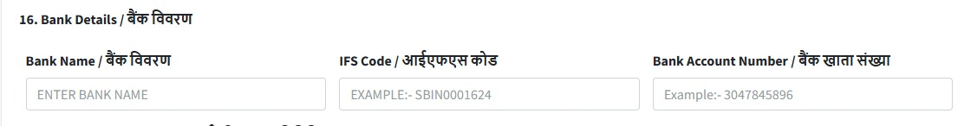 9. Enter the bank details of your business, i.e. “bank name, IFSC code and bank account number”.

10. Mention the major activity of your business i.e. “manufacturing or service”. In

case you have a combination of manufacturing and service business then

select the activity which is more prominent.

11. Once you select “Manufacturing or Service”, you can select the NIC code of

your activity from the dropdown. You can have multiple business activities

and accordingly multiple business activity codes can be selected from the

dropdown list.

12. Enter the number of employees you have against their gender:

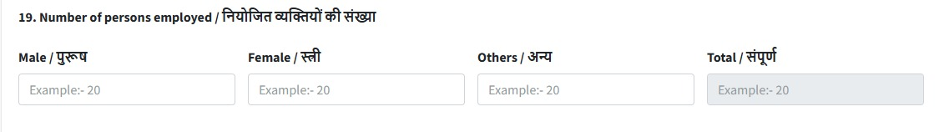

13. If you have filed ITR, the field ‘Investment in Plant and Machinery’ will be

disabled.

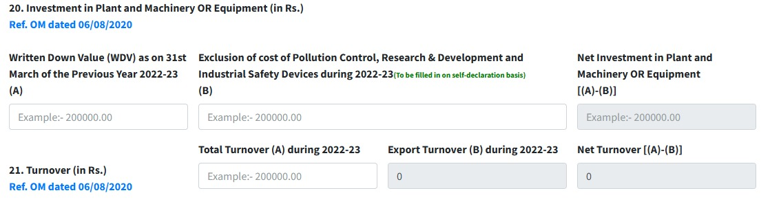

www.nettax.in | Connect with us: 1800 890 4841

www.nettax.in | Connect with us: 1800 890 4841

14. In case you have not filed the latest ITR or if you have filed ITR-4, you need

to manually enter the details of turnover and investment on self-declaration

basis.

15. Are you interested in getting registered on Government e-Market (GeM) Portal

- Please Select Yes or No

16. Are you interested in getting registered on TReDS Portals (One or More) -

Please Select Yes or No

17. Based on the details that you have filled, the form will auto-select the

applicable DIC for your business.

18. After all information has been filled select ‘“Submit & Get Final OTP’”. You will

receive an OPT on your Aadhaar- linked mobile number. Enter the verification

captcha. Select ‘Final Submit’.

**Step 6:** Print Udyam Registration

* After submitting the form, a pop-up will appear and a temporary Udyam

Registration number will be generated. Please write down this number as it is

needed to download the Udyam Registration certificate.

* Once the application has been submitted, the system will take a few days to

verify your details.

* These details will then be verified based on the information available against

your PAN, GST and Income Tax records.

* Enter the generated temporary Udyam Registration number and select

whether you want to receive the OPT on your mobile number or email

address. 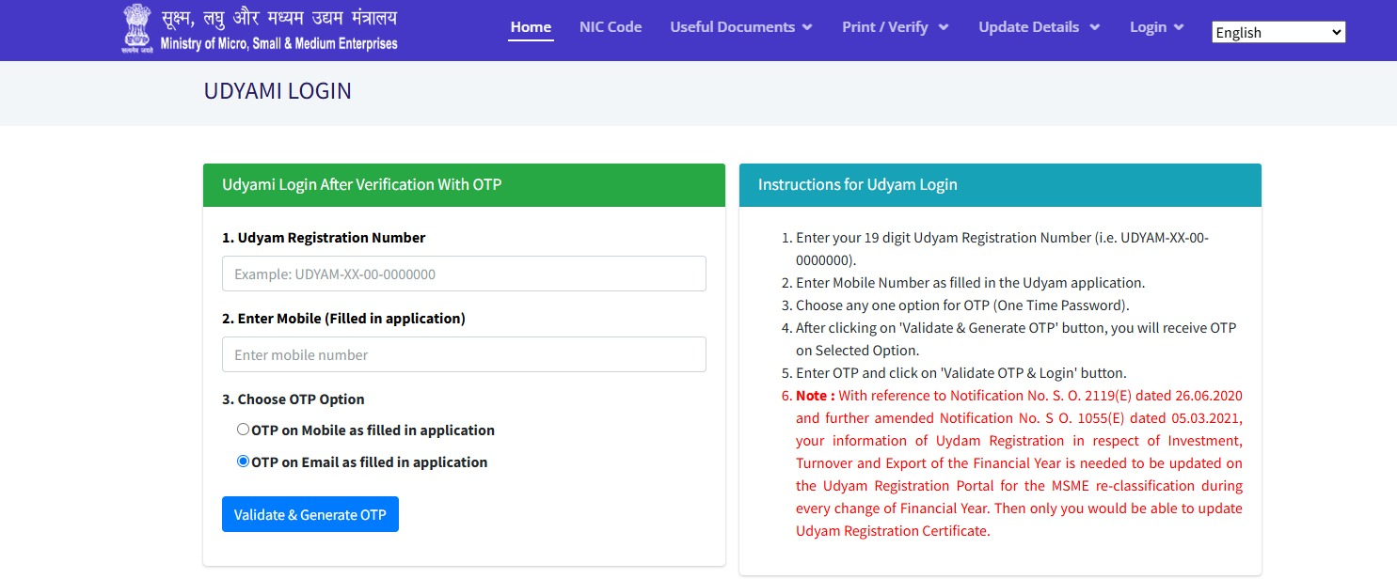

www.nettax.in | Connect with us: 1800 890 4841

www.nettax.in | Connect with us: 1800 890 4841

* If the details of the form are verified and found correct, you will be able to

download your 'Udyam Registration Certificate'.

**Documents Required to File Udyam Registration:**

To get Udyam Registration, you don’t need to submit any documents.

But to enter the information in the application form, you will need the following

supporting documents:

1. Aadhaar card of the applicant,

2. PAN card of the business (in case of proprietorship concern, proprietor’s PAN

is sufficient)

3. Address proof of business premises to enter details like the office address.

4. Certificate of Incorporation in case of a Company or Partnership Deed, in case

of Partnership or Shop Act Intimation or license, in case of other types of

entities for Date of Incorporation and Date of Commencement of Business.

5. Bank passbook or cheque or bank statement of the bank account that has

been opened in the name of the business.

6. Latest ITR and financials to enter the turnover and investment details.

**Benefits of Udyam Registration:**

1. It will be a permanent registration and serve as the basic identification

number for an enterprise.

2. It may also help MSMEs to avail the benefits of Schemes of the Ministry of

MSMEs, such as Credit Guarantee Scheme, Public Procurement Policy,

additional edge in Government Tenders & Protection against delayed

payments, etc.

3. Become eligible for priority sector lending from banks

4. MSME Registration is paperless and based on self- declaration.

5. There will be no need for renewal of Registration.

www.nettax.in | Connect with us: 1800 890 4841

www.nettax.in | Connect with us: 1800 890 4841

**FAQs**

**Q: Is it mandatory to get Udyam Registration?**

A - It is not mandatory to get Udyam Registration. However, all the benefits and

schemes launched or announced for MSMEs can only be availed if you have Udyam

Registration.

**Q: Earlier I had ‘Udyog Aadhar’, should I still get ‘Udyam Registration’?**

A - Yes. You need to register your business for “Udyam Registration” before 31

December 2021. After this date, the old “Udyog Aadhar Registration” will be

considered invalid.

**Q: Can new businesses apply for Udyam Registration?**

A - No, only existing businesses can apply for Udyam Registration.

**Q: Can a business have more than one Udyam Registration?**

A - No, a business cannot have more than one Udyam Registration.

www.nettax.in | Connect with us: 1800 890 4841

**Good Luck**

**For Your Business**

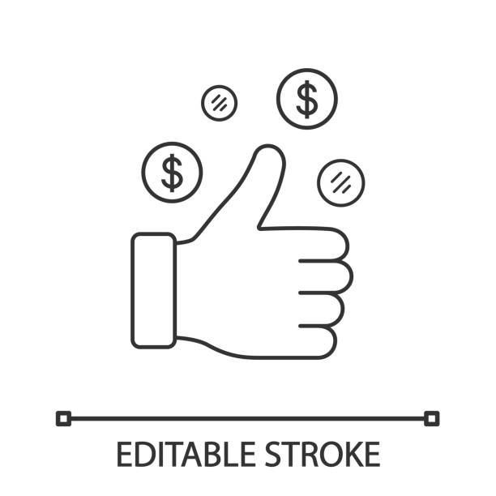Shop No 5, 1st Floor, Vallabh Vihar Park, Nr Bhagirath bungalows, Vijay Park BRTS, Ahmedabad - 382345