**TDS RETURN FILING**

**CHECKLIST**



www.nettax.in | Connect with us: 1800 890 4841

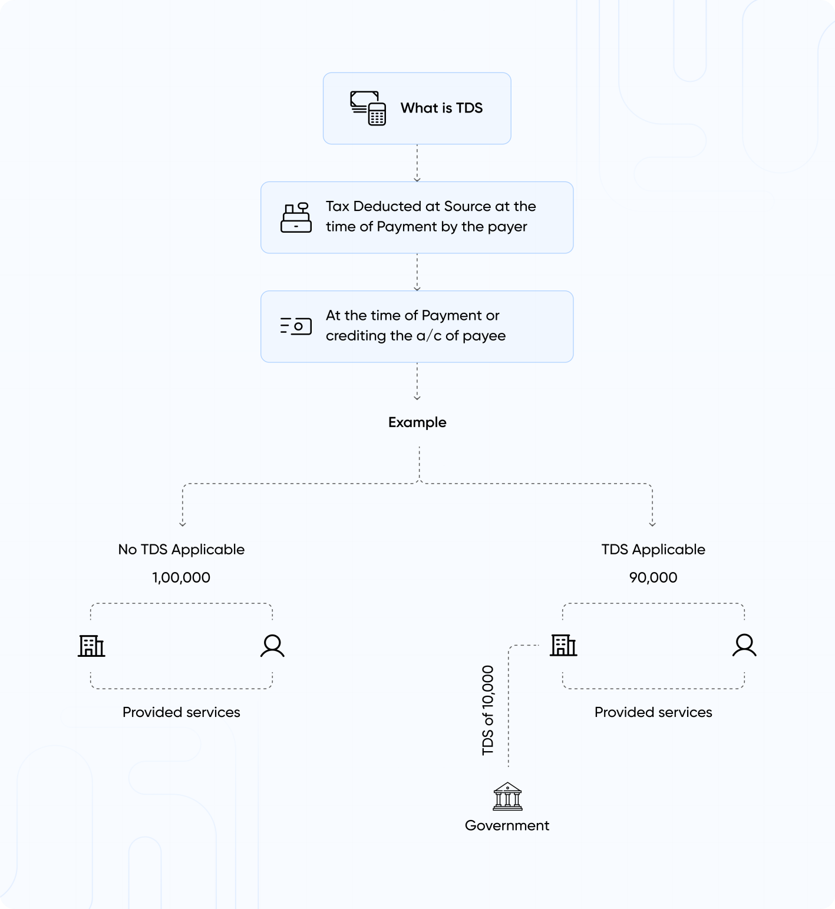TDS or Tax Deducted at Source is income tax reduced from the money paid at the time of making specified payments such as rent, commission, professional fees, salary, interest etc. by the persons making such payments. Usually, the person receiving income is liable to pay income tax. But the government with the help of Tax Deducted at Source provisions makes sure that income tax is deducted in advance from the payments being made by you. The recipient of income receives the net amount (after reducing TDS). The recipient will add the gross amount to his income and the amount of TDS is adjusted against his final tax liability. The recipient takes credit for the amount already deducted and paid on his behalf. This will help the government to collect the taxes in advance and to track the transactions in an effective manner. It reduces the chance of tax evasion by the payee.

www.nettax.in | Connect with us: 1800 890 4841

**Example of TDS**

Shine Pvt Ltd makes a payment for office rent of Rs 80,000 per month to the owner of the property. TDS is required to be deducted at 10%. Shine Pvt ltd must deduct TDS of Rs 8000 and pay the balance of Rs 72,000 to the owner of the property. Thus, the recipient of income i.e. the owner of the property in the above case receives the net amount of Rs 72,000 after deduction of tax at the source. He will add the gross amount i.e. Rs 80,000 to his income and can take credit of the amount already deducted i.e. Rs 8,000 by shine Pvt ltd against his final tax liability.

**How to Deposit TDS?**

Tax Deducted at Source has to be deposited via Income Tax Portal based on the TAN login. Direct tax payments facility has been migrated from OLTAS 'e-payment: Pay Taxes Online' to e-Pay Tax facility of e-Filing portal. You have to click on 'e-Pay Tax' option of Income Tax Department on https://www.incometax.gov.in/ to make direct tax payments including TDS.

**Types of TDS**

Here are some of the income sources that qualify for TDS:

* Salary
* Payments to Contractor
* Commission payments
* Sale of House
* Insurance Commission
* Interest on securities
* Interest other than interest on securities
* Rent Payment
* Professional fees
* Online Gaming
* Winning from games like a lottery, crossword puzzle, card, etc.

www.nettax.in | Connect with us: 1800 890 4841

**Good Luck**

**For Your Business**

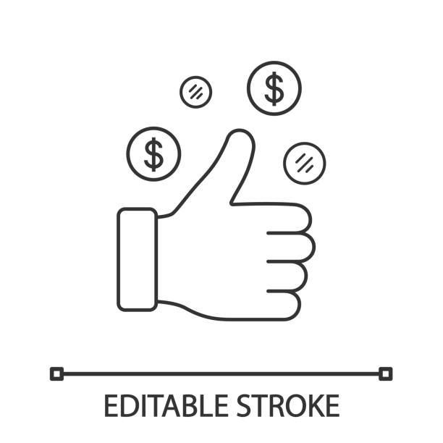

Shop No 5, 1st Floor, Vallabh Vihar Park, Nr Bhagirath bungalows, Vijay Park BRTS, Ahmedabad - 382345

www.nettax.in | Connect with us: 1800 890 4841