PATENT REGISTRATION

CHECKLIST

www.nettax.in | Connect with us: 1800 890 4841

www.nettax.in | Connect with us: 1800 890 4841

www.nettax.in | Connect with us: 1800 890 4841

**What is a Patent?**

A patent is a legal document that gives individuals or businesses the right to safeguard their inventions, preventing unauthorized import, production, or sale of their product. Inventors frequently opt to patent their creations to protect their innovative ideas from exploitation.

**What is Patent Registration?**

Patent Registration is a legal procedure that provides inventors with exclusive ownership and usage rights for their product, service, or technology. This means the inventor has a monopoly over their creation for as long as the patent is valid. Inventors and businesses must safeguard their innovative ideas and stop others from using, selling, or making their inventions without permission. Read about Patents (2nd Amendment) Rules, 2020

* **What it grants**: Inventors are granted the right to make, use, sell, and import their invention without others' permission.
* **How long it lasts**: The patent is usually valid for 20 years from the filing date.
* **Why it's important**: It protects inventors' ideas and rewards their efforts. It also allows inventors to capitalize on their intellectual property.

In India, the Indian Patent Office (IPO) handles patent registration. The IPO has branch offices in Delhi, Mumbai, Kolkata, and Chennai. The jurisdiction for filing a patent is usually based on the applicant's domicile, place of business, or where the invention originated

www.nettax.in | Connect with us: 1800 890 4841

**Importance of Patent Registration**

Patent Registration holds significant importance for various reasons:

* **Legal Protection**: It provides legal protection for the patent holder. In patent infringement, the patent holder has the right to take legal action and seek damages. Without registration, legal protection cannot be enforced.
* **Transferable Rights**: Patent registration allows the patent holder to sell or transfer the patent, generating revenue.
* **20-Year Validity**: Once registered, a patent is legally protected for 20 years.
* Competitive Advantage: It offers a competitive edge to businesses, preventing competitors from using the patented invention for similar products.
* **Asset Creation**: A patent is an intellectual property right and an exclusive asset for a business. It can be sold, transferred, or used for commercial agreements.

**What Can Be Patented in India?**

In India, various types of inventions are eligible for patent protection. These include:

* **Products**: This category covers new and inventive physical items, such as machines, devices, chemicals, pharmaceuticals, and manufactured goods.
* **Processes or Methods**: Innovative methods or processes that offer a novel way of accomplishing a specific task or producing a product can be patented. This may involve manufacturing processes, industrial methods, or new field techniques.
* **Machines**: Any new and useful machines or mechanical inventions, including those with innovative mechanisms or components, can be patented.
* **Manufactured Articles**: Items created through a novel process or having unique features can be patented as manufactured articles.
* **Chemical Compounds**: New and inventive chemical compounds, including pharmaceuticals, can be patented.
* **Biotechnological Inventions**: Innovations in biotechnology, such as genetic engineering, gene sequencing, and new biotechnological processes, are eligible for patent protection.
* **Software and Computer-Implemented Inventions**: In some instances, software and computer-related inventions can be patented, provided they demonstrate novelty and an inventive step.

www.nettax.in | Connect with us: 1800 890 4841

**What Cannot Be Patented?**

The Patent Act of 1970 specifies specific exclusions from patentability. Here's what cannot be patented:

* Inventions that violate natural laws.
* Inventions harmful to humans, animals, plant life, or the environment.
* Discoveries of scientific principles or abstract theories.
* Discoveries of naturally occurring living or non-living substances.
* Inventions that are merely a known process or machine unless they result in a new product.
* Simple mixtures that combine the properties of their components.
* Basic arrangements or rearrangements of common devices.
* Inventions excluded by the Patents (Amendment) Act, 2002.
* Methods for agriculture or horticulture.
* Processes related to medicinal, surgical, curative, diagnostic, therapeutic, or human/animal disease prevention.
* Inventions concerning plants, animals (including seeds, varieties, species), except microorganisms.
* Computer programs or mathematical methods.
* Creations related to literary, dramatic, musical, or artistic works, including films and television productions.
* Simple game-playing methods.
* Mere information presentation.
* Topography of integrated circuits.
* Inventions aggregating or duplicating known properties of components traditionally known.
* Inventions related to atomic energy (not patentable).

www.nettax.in | Connect with us: 1800 890 4841

## ****documents list****of ****patent****

* Application form in duplicate (Form 1).
* The provisional or complete specification in duplicate. If the provisional specification is filed, it must be followed by the complete specification within 12 months. (Form 2).
* Drawing in duplicate (if necessary).
* Abstract of the invention in duplicate.
* Information & undertaking listing the number, filing date & current status of each foreign patent application in duplicate (Form 3).
* Priority document (if the priority date is claimed) in convention application, when directed by the Controller
* Declaration of inventor-ship where the provisional specification is followed by complete specification or in case of convention/PCT national phase application (Form 5).
* Power of attorney (if filed through Patent Agent).
* Fees (to be paid in cash/by cheque/by demand draft)

www.nettax.in | Connect with us: 1800 890 4841

**Good Luck**

**For Your Business**

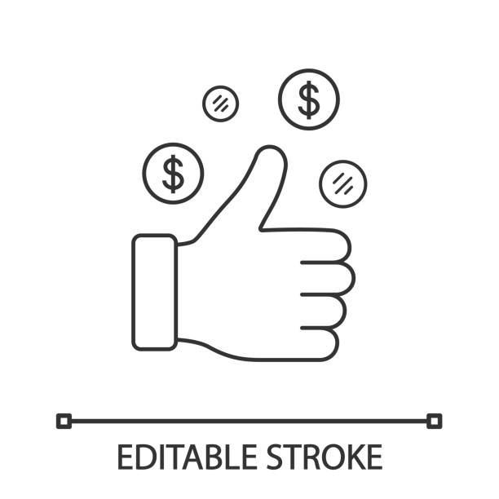

Shop No 5, 1st Floor, Vallabh Vihar Park, Nr Bhagirath bungalows, Vijay Park BRTS, Ahmedabad - 382345

www.nettax.in | Connect with us: 1800 890 4841

www.nettax.in | Connect with us: 1800 890 4841