IEC CODE REGISTRATION

CHECKLIST

www.nettax.in | Connect with us: 1800 890 4841

www.nettax.in | Connect with us: 1800 890 4841

www.nettax.in | Connect with us: 1800 890 4841

**IMPORT EXPORT CODE**

Starting and registering a business is an important step in an entrepreneur's journey and choosing the right form of business is equally important. Here, we will guide you on IEC registration that is how you can apply for import export code through LegalRaasta, what are its benefits, what are the documents required for the same.

**What is IEC ?**

IEC is known as many names like importer exporter code, import export code, import export license, import export number which comes under the foreign trade act, 1992. It is a 10 digit code which is provided by DGFT. Therefore, IEC is compulsorily required for import or export of any goods in and out of India. You can take IEC code in personal name and company name also. Any legitimate person or company starting a deal for International trade need lEC. -An lEC number issued to applicant shall be valid for all its divisions/ units/ factories/ branches. IEC is valid for lifetime and there is no need to renew the same.

**Benefits of Import Export code**

* On the basis of IEC, companies or firms can achieve profit on their exports/ imports from DGFT, Customs and export promotion council.
* IEC is necessary to import or export, without importer/exporter code no import or export shall be made by any person or entity.
* Taking your services or products to the international market will enlarge your businesses.

www.nettax.in | Connect with us: 1800 890 4841

**Steps involved in IEC (Import/Export Code) registration**

* Visit the DGFT website.
* Click on the ‘Services’ tab on the homepage.
* Select the ‘IEC Profile Management’ option from the drop-down list.
* A new page will open. Click on the ‘Apply for IEC’ option on the page.
* Click on the ‘Register’ option. Enter the required details and click on the ‘Sent OTP’ button.
* Enter the OTP and click on the ‘Register’ button.
* Upon successful validation of the OTP, you will receive a notification containing the temporary password which you can change after logging into the DGFT website.
* After registering on the DGFT website, login to the website by entering the user name and password.
* Click on the ‘Apply for IEC’ option on the DGFT website dashboard.
* Click on the ‘Start Fresh Application’ button.
* Enter the general information, details of proprietor/partner/director/Karta/managing trustee, bank information, other details, attach Digital Signature Certificate (DSC) and make the payment.
* After successful payment, it will be redirected to the DGFT website. The receipt will be displayed. Download the receipt for future reference.
* The IEC Certificate will be sent in the email. It can be downloaded after logging in to the DGFT website and clicking the ‘Print IEC’ option under the ‘IEC Profile Management'.

www.nettax.in | Connect with us: 1800 890 4841

**Required Documents**

* Individual’s, firm’s or company’s copy of PAN Card.
* Proprietor’s voter ID, Aadhaar card or passport copy.
* Proof of establishment, incorporation or registration of the partnership, society, proprietorship firm, company, HUF, etc.
* Proof of address of business premise, such as sale deed, lease deed, rent agreement or utility bills (electricity bill, telephone bill or mobile bill).
* Individual’s or company’s or firm’s cancel cheque copies of current bank accounts.
* A self-addressed envelope for delivery of IEC certificate by registered post.

**FAQ’s**

Q. Is IEC mandatory?

A. Yes. An Importer-Exporter Code (IEC) is mandatory for import to India or export from India. It is a significant business identification number for an import/export business. A person/entity cannot export or import without obtaining an IEC unless specifically exempted. However, IEC is not necessary for services exports, except when the service provider is taking benefits under the Foreign Trade Policy.

Q. How much time does it take to get the IEC code?

A. Once the online application is submitted by paying the appropriate fees and requisite documents, IEC will be auto-generated. The DGFT will send the IEC Certificate to an applicant through the e-mail.

Q. How can I print my IEC certificate?

A. You can take print out of your IEC certificate by the below process:

* Visit the DGFT website.
* Click on the ‘Services’ tab on the homepage.
* Select the ‘IEC Profile Management’ option from the drop-down list.
* A new page will open. Click on the ‘Print IEC’ option on the page.
* Verify your details and click on the ‘Print IEC’ button.

www.nettax.in | Connect with us: 1800 890 4841

Q. Should I update my IEC profile annually?

A. Yes. It is mandatory to update the IEC profile every year. In case of non-updation of the IEC profile, it will be deactivated. A deactivated IEC can be reactivated upon its successful updation. However, reactivation is subject to the condition that any other action should not be taken for violation of any provisions of the Foreign Trade Policy.

Q. Is Digital Signature Certificate (DSC) required to apply for IEC?

A. A Digital Signature Certificate (DSC) is not compulsory to apply for an IEC. The IEC application can be signed through Aadhaar authentication. DSC has been introduced in IEC to strengthen the IEC issuance and modification processes.

www.nettax.in | Connect with us: 1800 890 4841

**Good Luck**

**For Your Business**

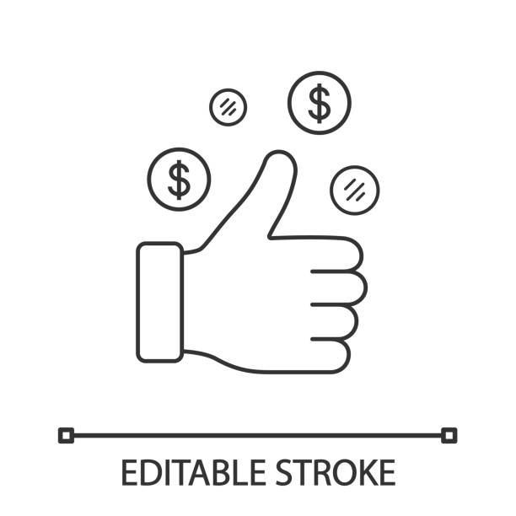

Shop No 5, 1st Floor, Vallabh Vihar Park, Nr Bhagirath bungalows, Vijay Park BRTS, Ahmedabad - 382345

www.nettax.in | Connect with us: 1800 890 4841

www.nettax.in | Connect with us: 1800 890 4841