**GEM REGISTRATION**

**CHECKLIST**



www.nettax.in | Connect with us: 1800 890 4841

**What is GeM Registration?**

GeM registration's full form is Government e-Marketplace (GeM), an online platform for public procurement of goods and services by central and state government organizations.

Public procurement has always been an essential part of government activities. The government's intention behind introducing GeM was to enhance transparency, efficiency, and speed in public procurement.

GeM provides the tools of e-bidding, reverse e-auction, and demand aggregation to facilitate the government users, achieve the best value for their money.

* Buyers

Government departments, organizations, and PSUs can use GeM to buy goods and services directly from manufacturers and private traders.

* Sellers

Manufacturers, small dealers, and service providers can use GeM to sell their products and services to government departments.

The GeM portal was introduced by the Commerce and Industry Minister in 2016 as part of the Make in India initiative. The portal's goals are to:

* Improve the efficiency and transparency of public procurement
* Streamline the process of acquiring supplies and stores
* Provide tools like e-bidding and reverse e-auction to help government users get the best value for their money

www.nettax.in | Connect with us: 1800 890 4841

**Benefits of GEM Registration**

GEM registration gives you an edge by providing access to the national public procurement market. Sellers are assured of timely payment on it while buyers can enjoy the easy-to-use interface. The benefits of obtaining Registration at the GEM Portal are as follows:

**Benefits of GEM Portal Registration for Buyers**

Given below are the significant benefits of GEM portal registration for buyers-

* List of products for individual categories of goods or services with offers
* Availability of various facilities, such as search, compare, select and buy
* Enables buying online as per one’s own requirement, i.e., as and when required
* Transparency and ease of buying
* It ensures a continuous vendor rating system
* Up-to-date, user-friendly dashboard for monitoring supplies, buying and making payments
* Provisions of an easy return policy

**Benefits of GEM Registration for Sellers**

GEM registration is one of the crucial aspects sellers can't ignore. Given below are some of the relevant benefits of GEM registration for sellers-

* Direct access to all departments of Government
* One-stop-shop for marketing with minimal effort
* One-stop-shop for bids or a reverse auction on products or services
* New product suggestions facility available for sellers
* Online grievance redressal for quick resolution
* Dynamic pricing, i.e., price changes based on market conditions
* Seller-friendly dashboard for monitoring supplies, selling and payments
* Uniform and consistent purchase procedures
* OEM and MAIT Recommendations
* Provision for North-East, J & K

www.nettax.in | Connect with us: 1800 890 4841

**Required Documents as a Seller for GEM Registration**

Given below are the significant required documents as a seller for GEM registration-

* Aadhar Card of Proprietor/Director/Authorized Person
* Cancelled Cheque
* PAN Card of Proprietor
* PAN Card of Company in case of LLP, Pvt. Ltd and Partnership
* MSME Certificate
* GST Certificate
* NSIC
* ISO
* Trademark Registration
* ITR of Last 3 Years

**Required Documents as a Buyer for GEM Registration**

Given below are the significant required documents as a buyer for GEM registration-

* Aadhar Card of Head of Department (Govt. Department)
* Official Email ID
* The Mobile Number of the Authorized Person should be Registered with an Aadhar Card
* Organization details such as
* Name of the Department
* Landline Number
* Ministry Complete Address with PIN

www.nettax.in | Connect with us: 1800 890 4841

**FAQ’s**

**Q. What are the types of Registration under the Government E- Marketplace?**

**A**. There are two types of GEM Registration. The first one is Primary Registration, which is for buyers, and the second one is Secondary Registration, which is for sellers.

**Q. What does GEM stand for?**

**A**. GEM stands for government e-marketplace. It is a renowned digital e-commerce portal empowering sellers.

**Q. Is Aadhar Mandatory for Seller Registration?**

**A**. No, as per the updates, Aadhar is not mandatory for seller registration. Sellers are blessed with the option to use their personal PAN to verify their identity while proceeding with the registration.

**Q. Can a reseller and an OEM offer products/services on Gem?**

**A**. Yes, if you are a reseller or an OEM, you can offer products or services on GeM. However, at the time of uploading your product, you need to choose whether you are an OEM or a reseller for that significant product.

**Q. What is SAHAY?**

**A**. SAHAY is an online platform that provides sellers with a load against orders and accepted invoices. Proprietors registered as Sellers on the GEM Portal opt for SAHAY.

**Q. To register on GEM as a seller, Do I need a DIPP Number?**

**A**. In order to register on GEM, a DIPP Number is required only for startups.

**Q. What is the GeM Portal in India?**

**A**. The government e-marketplace (GeM) is a known and an innovative platform for public procurement in India. It came into light on 9 August, 2016 with an objective of creating transparent as well as open procurement platform for government buyers.

**Q. Why is GeM required?**

**A**. GeM strives to boost efficiency, maintain transparency as well as speed in public procurement. It furnishes the tools of reverse e-auction, e-bidding, and demand aggregation. Thus, GeM is required.

**Q. Who is eligible to register on the GeM portal?**

**A**. Any business entity, including startups, MSMEs, as well as large enterprises providing goods as well as services can register on GeM portal.

www.nettax.in | Connect with us: 1800 890 4841

**Q. Can a startup register on GeM?**

**A**. Yes, startups can register on the GeM portal. Furthermore, they are encouraged and pushed to participate in government procurement.

**Q. What is the process of bidding on GEM?**

**A**. Registered sellers can participate in tenders or bids by submitting their proposals online via the GEM portal.

**Q. Can foreign companies register on GeM?**

**A**. Yes, foreign companies can proceed with GeM registration. They must meet the key requirements and have a robust presence in India.

www.nettax.in | Connect with us: 1800 890 4841

**Good Luck**

**For Your Business**

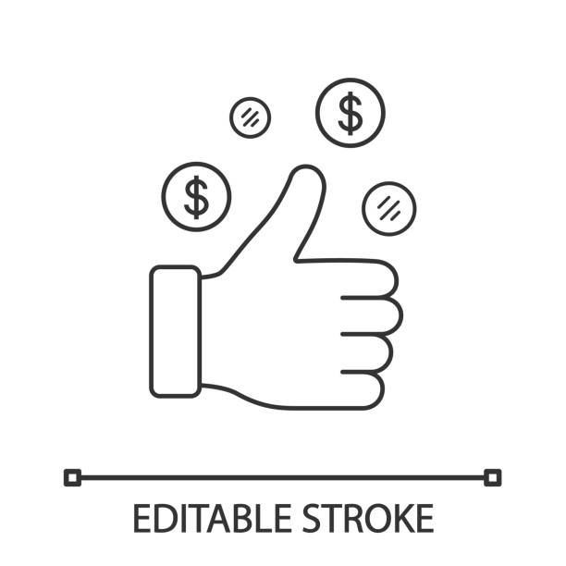

Shop No 5, 1st Floor, Vallabh Vihar Park, Nr Bhagirath bungalows, Vijay Park BRTS, Ahmedabad - 382345

www.nettax.in | Connect with us: 1800 890 4841