**FSSAI REGISTRATION**

**CHECKLIST**



www.nettax.in | Connect with us: 1800 890 4841

**FSSAI REGISTRATION**

FSSAI is a government body responsible for protecting and promoting public

health. It was established under the Ministry of Health & Family Welfare and looks into the regulation and supervision of food safety.

Under FSSAI, a business owner has to apply either for FSSAI Registration or FSSAI Licence. The applicability of FSSAI registration or license depends on the annual

turnover of one’s business and other factors like: Whether the business is located in more than one state, what is its quantity of production, its nature, etc.

For businesses, like import export and online selling of goods on e-commerce websites, it is mandatory to apply for FSSAI License, even if its turnover is within the prescribed limit prescribed for FSSAI Registration.

Applicability of FSSAI Registration or License based on the annual turnover of a business:

(What is the applicability for FSSAI Registration and Licence based on turnover?)

|  |  |
| --- | --- |
| Annual Turnover | What is required - Registration or License? |
| Below Rs. 12 Lakhs | Registration |
| Rs. 12 Lakhs - Rs. 20 Crore | State License |
| Above Rs. 20 Crore | Central License |

# Generating E-Challan (for Maharashtra only):

Before starting with the registration process an applicant has to ﬁll the online challan available on the following website:

https://gras.mahakosh.gov.in/echallan/challan/views/frmDeptechallan_entry.php (link only for Maharashtra)

* Select the Revenue option.

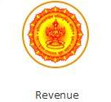

www.nettax.in | Connect with us: 1800 890 4841

* Select the following details:
  1. Department name - i.e., Food and Drugs Administration
  2. Payment type - i.e., Food Registration or Food License
  3. District
  4. Office name, - a dropdown appears according to the district selected
  5. Scheme name - i.e., receipts under the Food and Drugs Act
  6. Period year, and duration - i.e., annual, half-yearly, monthly, etc.
  7. Form ID - i.e., for Form A
* The applicant has to enter the payment amount - i.e., Rs. 100/-, bank details, applicants’ details and payments details.
* The applicant has to select the mode of payment - i.e., e-payment or payment across the bank counter.
* On payment, the applicant will receive GRN.
* The process must be completed within 7 days from the date of receiving the GRN., if not, the applicant will have to make a payment and generate GRN again to continue the process.

# Payment procedure for states other than Maharashtra:

The FSSAI website (https://foscos.fssai.gov.in/) guides users on how and where to make payment for FSSAI Registration



# How to apply for FSSAI Licence or Registration? Applying for FSSAI Registration:

**Step 1:** User must login by clicking on “Apply for Registration Certificate (Petty Food Business Operators) Fee: Rs.100 per year” - as shown in the figure below:

www.nettax.in | Connect with us: 1800 890 4841

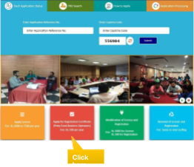

**Step 2:** Enter email-ID or mobile number and submit. A verification code (OTP) will be sent to the given email ID or mobile number. Enter the code and submit.

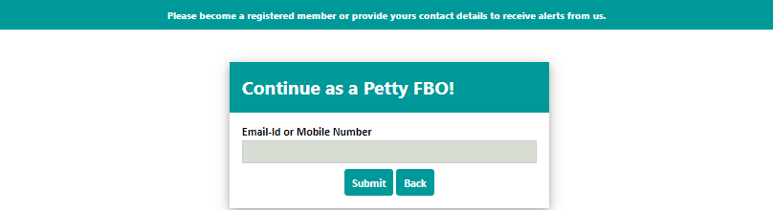

**Step 3:** Select the state and read the note before proceeding.

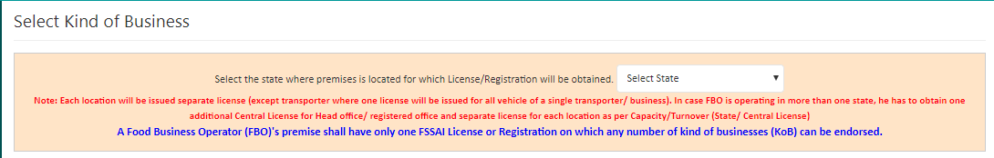

**Step 4:** Read the Group Heads of Kind of Business.



www.nettax.in | Connect with us: 1800 890 4841

**Step 5:** Click on Kind of Business relevant to the food business. The user can then read the definition of all kinds of business listed. Then proceed to click on the radio button below.

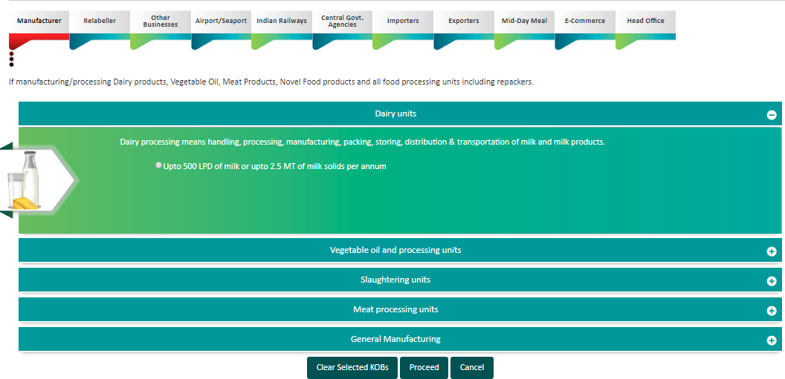

www.nettax.in | Connect with us: 1800 890 4841

**Step 6:** Fill in the mandatory fields as shown in Form A.

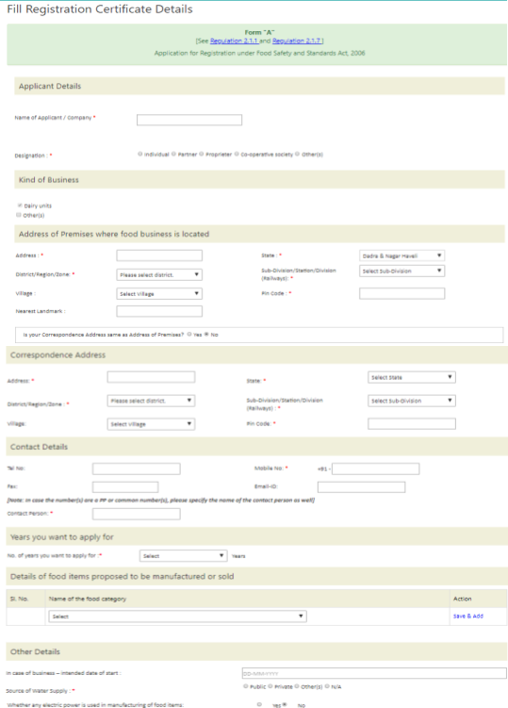

www.nettax.in | Connect with us: 1800 890 4841

**Step 7:** Upload the documents, pay the fees and submit the application.

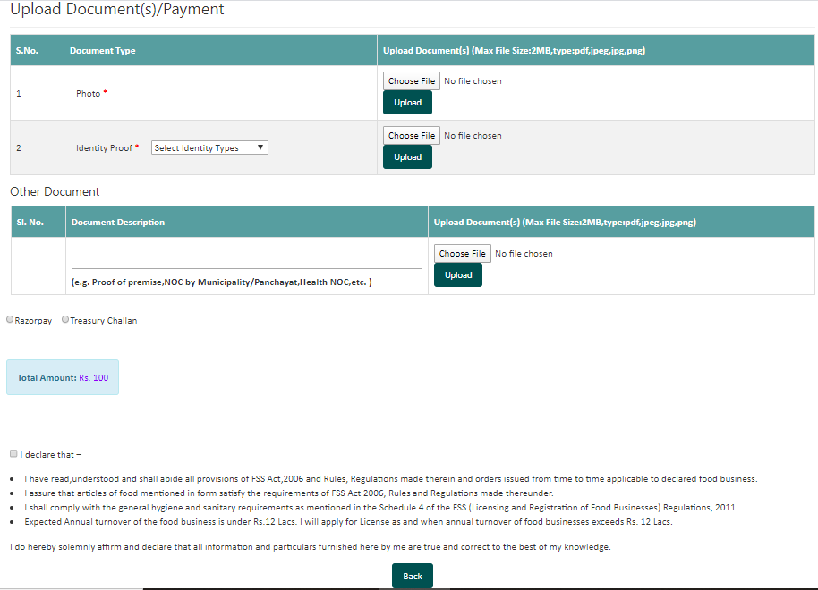

**Step 8:** After successfully completing the payment, a receipt will be generated with a 17-digit reference number that can be used for future reference.

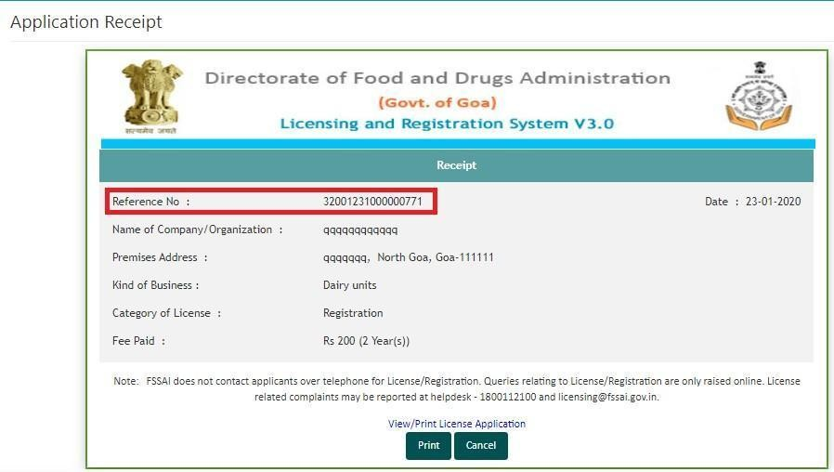

www.nettax.in | Connect with us: 1800 890 4841

**Step 9:** The user can then track the status of the application through the Homepage with the reference number - foodlicensing.fssai.gov.in

# FSSAI Registration Certiﬁcate:

* The applicant will receive a status update on whether the form has been accepted or rejected. This takes approximately 7 working days from the date of submission.
* In case the form is reverted the applicant will receive a notification from the Registration Authority, on his registered mobile number or mail ID. He can

then check why the form has been reverted and either have to give clariﬁcation or submit additional documents. The applicant has to submit the requested documents by an authorised signatory within 30 days, else it will be rejected.

* Within 30 working days of submission of the form, the Registration Authority will grant registration.

# List of documents for FSSAI Registration:

(Which documents are required for FSSAI Registration?)

1. Identity Proof - Voter’s ID Card, PAN Card, Driving Licence, Passport, Aadhaar Card, Senior Citizen Card, IDs issued by a government department.
2. Scanned copy of the applicant’s photograph
3. Proof of Address of businesses activity (if address is other than that mentioned in the Photo ID Card)
4. Trade license/ NOC from oOwner or Municipal or society or gram panchayat. Health NOC is required on a case- to- case basis.

www.nettax.in | Connect with us: 1800 890 4841

# Information required for FSSAI Registration:

(Which information is required for FSSAI Registration?)

1. Name of the business.
2. Type of business entity.
3. Turnover of the business.
4. Contact details of the business (email address, phone number).
5. Address of the business.
6. Brief description of business activity.
7. Product category of manufacture or trade.
8. Annual quantity of production.
9. Date of commencement of business.
10. In the case of the seasonal business, the duration of business (i.e., the number of months when the business will be operating).

www.nettax.in | Connect with us: 1800 890 4841

# FAQs

**Q. Is FSSAI applicable to all food businesses?**

A: FSSAI is applicable to all types of food businesses, and its applicability is the same throughout India.

**Q. Which factors affect FSSAI Registration and License applicability?**

A: Applicability of FSSAI Registration or Licence depends upon factors like the size of the business, nature of the business, annual turnover, production quantity, business operations from multiple states, etc.

**Q. Should FSSAI be obtained before Shop Act?**

A: You need to form a business entity, apply for either FSSAI Registration or Licence, and then obtain Shop Act.

**Q. Which safety standards should a Food Business Operator (FBO) follow?**

A: FSSAI has issued Food Safety and Standards (Licensing and Registration of Food Businesses), 2011 which has detailed information on the safety and hygiene standards that should be followed by various types of food business, and for various types of food ingredients.

All amendments, updates to the above-stated regulations, and even the directions issued by FSSAI should also be followed by every Food Business Operator.

**Q. What is the Food Safety Display Board (FSDB)?**

A: Food Safety Display Boards (FSDB) refers to informative boards that display food safety and hygiene practices to be followed by FBO in their establishment. It also contains FSSAI Registration/Licence number, contact details for customer feedback. The FSDBs are colour coded for different kinds of food businesses to be easily recognised by consumers.

**Q. What is Food Safety Training Certiﬁcation Training (FoSTaC Training)?**

A: All food businesses must have at least one trained and certiﬁed “Food Safety Supervisor” for every 25 food product handlers. Such training and certiﬁcation is given through FOSTAC training. FSSAI has Certiﬁed Training Partners to give FoSTaC Training. This is a mandatory requirement.

www.nettax.in | Connect with us: 1800 890 4841

www.nettax.in | Connect with us: 1800 890 4841

**Good Luck**

**For Your Business**

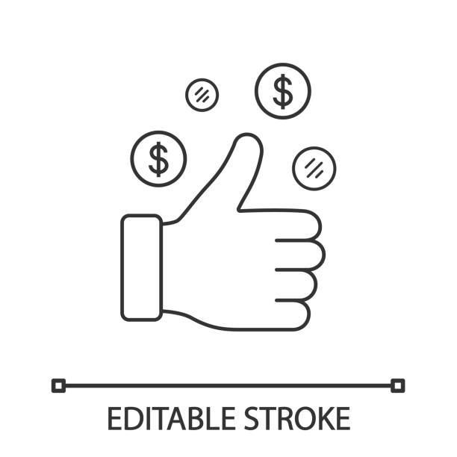

Shop No 5, 1st Floor, Vallabh Vihar Park, Nr Bhagirath

www.nettax.in | Connect with us: 1800 890 4841

bungalows, Vijay Park BRTS, Ahmedabad - 382345

www.nettax.in | Connect with us: 1800 890 4841