Digital Signature authority partner

www.nettax.in | Connect with us: 1800 890 4841

www.nettax.in | Connect with us: 1800 890 4841

www.nettax.in | Connect with us: 1800 890 4841

**Authority (RA) Digital Signature**

A Registration Authority (RA) is an entity that is responsible for accepting requests for digital certificates and authenticating the entity making the request. The RA acts as the mediator between the end-user and the Certificate Authority (CA).

**Benefits of Digital signature partner program**

* Increased Revenue: Generate additional revenue by selling digital certificates.
* Enhanced Credibility: Partnering with a recognized CA enhances your business credibility.
* Customer Trust: Offer secure and trusted digital certificates to your customers.
* Support and Training: Receive support and training from the CA to effectively sell and manage digital certificates.

**How do I start a digital signature business?**

To start a digital signature business, you can:

1. Join a DSC partner/reseller program offered by an authorized digital signature certificate provider.
2. Register yourself under the Approved Certifying Authority of India.
3. Obtain the necessary certifications and licenses.
4. Partner with Certification Authorities (CAs) authorized to issue DSCs.
5. Research and select CAs based on their reputation, product offerings, and support.

A DSC partner/reseller program is designed for companies that sell Digital Signature Certificates (DSC).

www.nettax.in | Connect with us: 1800 890 4841

# Documents For partner

The documents required to become a Digital Signature authority partner include:

* Business Registration Documents
* Identification Proofs
* Address Proofs
* Any other specific documents required by the Certificate Authority

www.nettax.in | Connect with us: 1800 890 4841

**Good Luck**

**For Your Business**

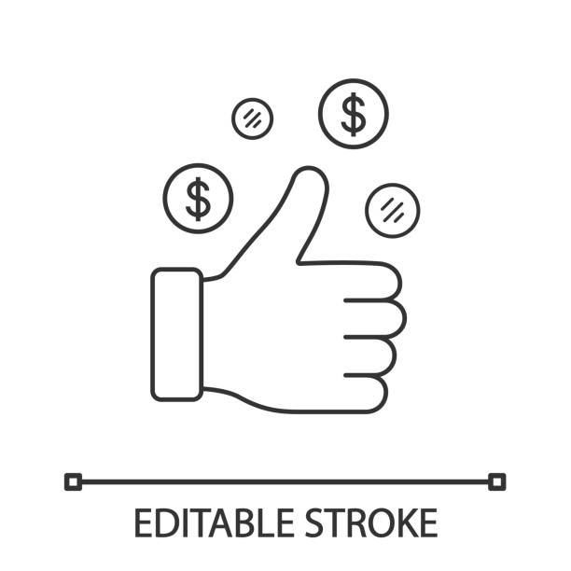

Shop No 5, 1st Floor, Vallabh Vihar Park, Nr Bhagirath bungalows, Vijay Park BRTS, Ahmedabad - 382345

www.nettax.in | Connect with us: 1800 890 4841

www.nettax.in | Connect with us: 1800 890 4841